Idempotent Matrix

Def

$$A^{2}$$ = $$A$$

Property

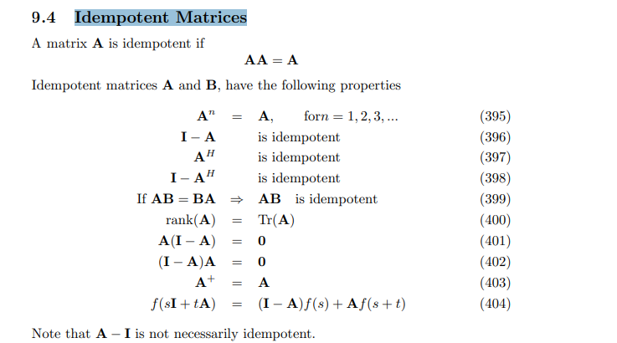

Proof

Proof by induction

Base step

$$A^{2}$$ = $$A^{}$$

Inductive step

By inductive hypothesis, on has

$$A^{k}$$ = $$A^{}$$

which implies

=> $$A^{k+1}$$ = $$A^{k}A$$ = $$AA$$ = $$A$$

$$\left(I−A\right)\left(I−A\right)$$ = $$II−IA−AI+AA$$ = $$I−A−A+AA$$ = $$I−A$$

$$A\left(I−A\right)$$ = $$AI−A^{2}$$ = $$A−A$$ = $$0$$

$$\left(I−A\right)A$$ = $$IA−A^{2}$$ = $$A−A$$ = $$0$$

Ref

[Wayback Machine (archive.org)](https://web.archive.org/web/20090521075124/http://www2.imm.dtu.dk/pubdb/views/edoc_download.php/3274/pdf/imm3274.pdf)